The CPU Strain of Consistent Auto-play

Clear Liu
Department of Computer Science
MacEwan University
Edmonton, Canada
Liuc44@mymacewan.ca

Abstract—Auto-play in fast-paced games poses a significant threat to game development. This paper reveals the comparative impact of auto-play mechanics on a CPU within Unity, a game development platform [4]. Using Unity’s built-in Profiler, the experiment setup follows, where bullets are fired at predefined intervals of 2, 3, …, 6 seconds (auto-play). The study provides clarity into resource allocation in games employing these mechanics [3]. It is evident that shooters, RPGs, and real-time strategy games all heavily rely on this basic concept. By revealing the CPU strains of these predefined intervals, game developers can make informed decisions to optimize performance while meeting expectation of players’ standards.
Keywords—Unity Profiler, Auto-Play, CPU Usage, Manual Action, Game Development, RPGs, Shooters, Strategy Games, Game Performance, Unity, Game Optimization, Users, Performance Analysis, Tower Defense Game

Introduction

Games evolve, as do the challenges of creating memorable experiences for players. Auto-play is a new mechanic in modern games that provides uniqueness in gameplay. A game that lags can ruin a player’s time and investment, which is why gameplay mechanics like auto-play threaten performance optimization [4], a top priority every game developer must foresee. A running test, mainly the CPU, will reveal the extent of how dangerous an auto-play feature can be. The document will also include memory usage as a bonus. Assuming this analogy, you are tasked to standstill holding 10kg or 50kg; if you choose 10 kilograms, you will have to stand for 1 minute and 10 seconds for 50kg. The question is, which would put more strain on the session by the end? In our terms, will having slowly generated graphics be better than quickly generated graphics and prove to be more resourceful within the completed time?

Mehodology

Setup in Unity
On the left side of the scene, we have a tower that will spawn three fireballs, and on the right side, we have three similar goblins approaching the building, each spaced out evenly. A fireball spawned will immediately one-shot a goblin as it travels to the right side horizontally at a constant speed. Players can select whether to shoot three fireballs in predefined intervals of 0s, .5s, 1.5s, or 2s.
For each scenario the game will end as soon as the third goblin is destroyed.
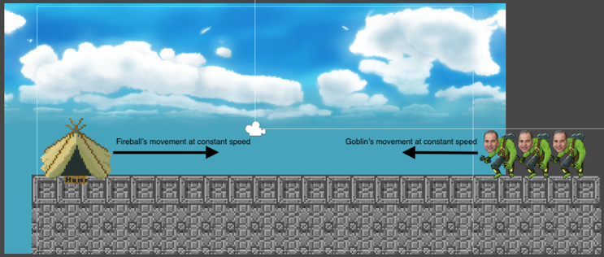
```SpawnFire.cs
void Update(){
timer -= Time.deltaTime;
if(timer <= 0 && fired < 3){
Instantiate(firePrefab, …, Quaternion.identity);
fired+=1;
time = coolDown;
}
}
```

```GoblinScript.cs
void Update(){
if(health <= 0){
Destroy(gameObject);
howManyDestroyed += 1;
if(howManyDestroyed == 3)
EditorApplication.ExitPlaymode();
}
}
```

Unity Profiler

Using Unity’s Profiler, a built-in performance analysis tool [5] that allows developers to view diagnostics on system resources upon playing their game, such as CPU, GPU, memory, and rendering. Its intuitive interface showcases and categorizes these factors, which we can monitor strictly the CPU mechanics.

Data Collection
Upon exiting Unity’s Play Mode (a built-in gameplay preview) the frame # and its total time to render that frame using CPU. Please see the following sample below.
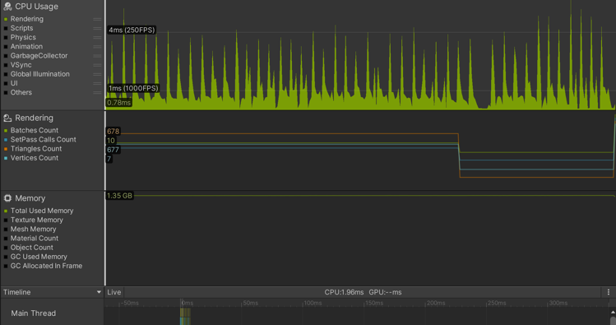
Now we note the following:
Frame # | Time to Render (ms)
1 | 1.96
2 | 1.77
3 | 2.86

This is from our recorded logs of shooting a fireball every 2s three times and stopping when the third goblin object gets destroyed as the final frame. The entire area of the graph, or in our case simply summing the whole “Time to Render” column due to our data points being extracted one frame at a time, will showcase if it is worth completing an auto-play task quickly with more resources for a short amount of time vs minimal resources but straining the CPU for a more extended amount of time. Assuming all three goblins were destroyed within these three frames, the total strain on CPU = (1.96+1.77+2.86)ms = 6.59ms. The lower the “ms” (or milliseconds), the more optimal for the CPU.

Results
The following tables are collected data frame by frame on the total time the CPU was put into operation until the final objective is completed (third goblin being destroyed). The game is set to a fixed 29.1785 frames per second.
- Every 2 seconds
Frame # | Time to Render (ms)
1-30 | 71.51
31-60 | 74.92
61-90 | 70.28
91-120 | 76.43
121-150 | 75.91
151-180 | 70.92
181-210 | 74.35
211-240 | 70.01
241-270 | 76.56
271-300 | 94.4
- The sum of 30 frames in one cell
- A total of 300 frames. CPU Strain: 755.29ms. Memory: 1.33GB Peak Render: 12.71ms @ frame 297
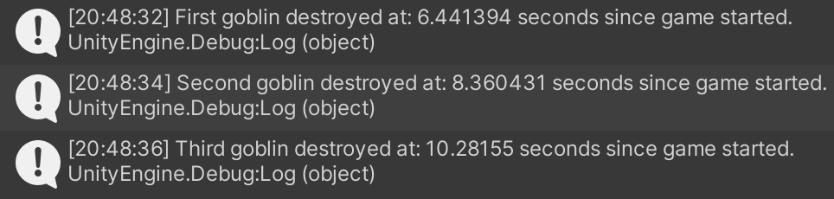
---
- Every 1.5 seconds
Frame # | Time to Render (ms)
1-30 | 69.58
31-60 | 70.82
61-90 | 69.01
91-120 | 68.20
121-150 | 72.43
151-180 | 70.08
181-210 | 71.20
211-240 | 69.71
241-270 | 80.78
271 | 1.29
- The sum of 30 frames in one cell
- A total of 271 frames. CPU Strain: 643.10ms. Memory: 1.29GB. Peak Render: 13.33ms @ frame 266.
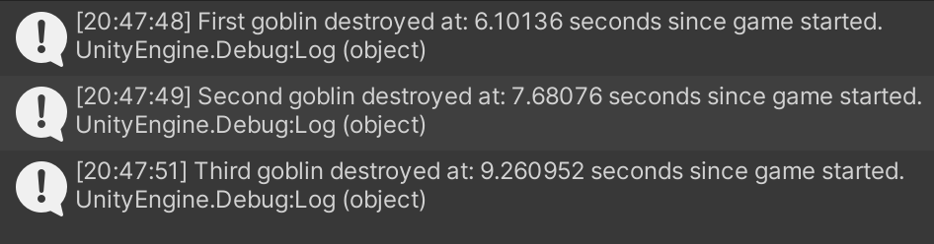
- Every 1 second
Frame # | Time to Render (ms)
1-30 | 67.31
31-60 | 71.52
61-90 | 67.71
91-120 | 66.58
121-150 | 70.38
151-180 | 68.51
181-210 | 68.02
211-240 | 67.06
241 | 6.39
- The sum of 30 frames in one cell
- A total of 241 frames. CPU Strain: 553.48ms. Memory: 1.27GB. Peak Render: 6.39 @ frame 241.
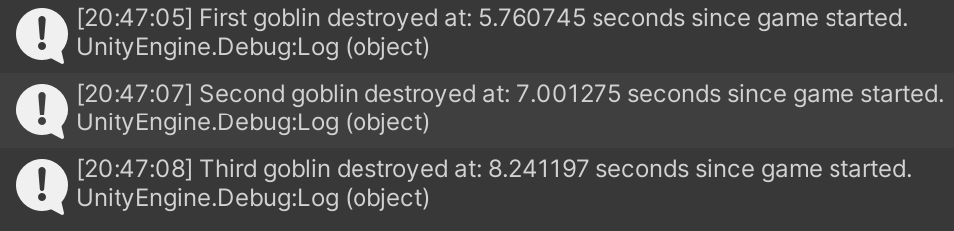
---
- Every 0.5 second
Frame # | Time to Render (ms)
1-30 | 68.98
31-60 | 68.64
61-90 | 67.58
91-120 | 68.33
121-150 | 72.75
151-180 | 67.81
181-210 | 66.81
211 | 2.15
- The sum of 30 frames in one cell
- A total of 211 frames. CPU Strain: 483.05ms. Memory 1.27GB. Peak Render: 5.55ms @ frame 66.
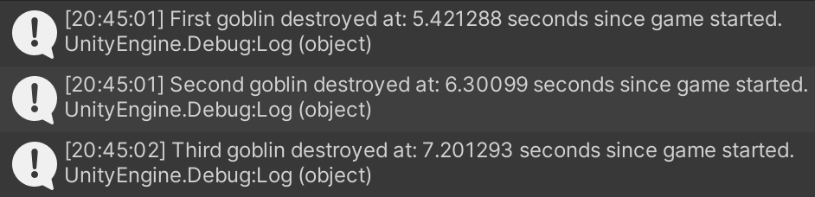
---

Visit the following link to see full raw details:
https://klearliu.github.io/Research-Paper-The-CPU-Strain-of-Consistent-Auto-Play/
Remove any spaces in URL if present.

Our fourth testing demonstrates the most efficient performance in terms of CPU strain. It records the lowest CPU strain at 483.05ms across a total of 211 frames with memory consumption at 1.27GB and peak render time of 5.55ms at frame 66. This implies that in auto play games opting for slower graphics generation (like holding 10kg for a longer duration) proves to consumes more resource and is less efficient when balancing strain on the CPU with the time required to complete tasks.

Figure 1 (Highest CPU Strain 755.29ms)
This scenario involves the highest number of on-screen elements, such as the most fireballs on screen and all three goblins still alive. More objects demand frequent calculations for collision, physics, and rendering thus leading to a higher CPU strain
Figure 2 (CPU Strain: 643.10ms)
Slightly fewer objects are present on screen compared to Figure 1 thus leading to a lower CPU strain. Out of the 4 figures, figure 2 has the highest peak render time (13.33ms @ frame 266) and suggests that there was simultaneous rendering of several effects and textures.
Figure 3 (CPU Strain: 553.48ms)
The objects present on screen are reduced further, leading to a less crowded gameplay scenario. Noticing that a lower peak render time of (6.39ms at frame 241) strongly implies a more balanced task with fewer spikes in computational demand.
Figure 4 (CPU Strain: 483.05ms)
Objects present on the screen are at its fewest compared to the other figures, such as fewer fireballs and goblins combined on screen. It also utilizes more efficient rendering for objects off-screen.

From our findings we can hypothesis that on-screen elements increase CPU strain and render times naturally rises, especially if there are dynamic elements as it requires additional calculations for effects, physics, and layering.
From figure 4 we can draw the importance of balancing visual effects, for example fast auto play features that leads to more objects being off-screen sooner uses lower textures and reduces CPU strain.
Before we can verify this hypothesis, we must run analysis of variance (ANOVA) [2].

Abbreviations and Acronyms
H₀, Null hypothesis: A statement that there is no significant difference between the data sets.
H_{a}, Alternative hypothesis: A statement that there is a significant relationship between the data sets.
α, Significance level:
df, Degrees of freedom
k, Total figures
N, Summation of all observed data
G, Summation of all measured data
x̄_{n}, mean of data set n
x̄, mean of all data
SS, Sum of squares
MS, Mean of squares
F, ratio of mean squares

Equations & Table
df_{between} = k-1 
df_{within} = N-k 2
F-Table 3
x̄ = G/N 4
F-Table 5
SS_{total} = ∑(x- x̄)² 6
SS_{within} = ∑(x_{n} - x̄_{n})² 7
SS_{between} = SS_{total} – SS_{withi} 8
MS_{between} = SS_{between}/df_{between} 9
MSwithin = SS_{within}/df_{within} 10
F_{static} = MS_{between}/MS_{within} 11

Calculations
Our hypothesis follows as:
H₀: μ1 = μ2 = μ3 = μ4 (no significant difference)
H_{a}: At least 1 difference among the means
α = 0.05

Finding Fcrit:
df_{total}: df_{between} + df_{within} = 1023

Using F-table [1] with α = 0.05, Fcrit = 2.37

Means and Grand Mean:
x̄1 = 2.51763; x̄2 = 2.37306;
x̄3 = 2.29660; x̄4 = 2.28934
x̄ = G/N = 2434.82/1023 = 2.38018

Sum of Squares:
SS_{total} = 1694.56357
SS_{within} = 1685.45690
SS_{between} = 9.10667

Mean Squares:
MS_{between} = 3.03556
MSwithin = 1.65241

F_{static}:
F_{static} = 1.83705

Result:
F_{static} < F_{crit}, therefore no significant difference.

Conclusion
Upon testing substantial differences, our null hypothesis holds no significant differences in these findings.
We conclude opting for slower graphics generation does not have a significant difference for consumes more resource and is not considered to be less efficient when balancing strain on the CPU with the time required to complete tasks.

References
- F. Jim, “Statisics by Jim” statisticsbyjim.com. https://statisticsbyjim.com (accessed Dec 5, 2024).
- C. Aaron, “Qualtrics” qualtrics.com. https://www.qualtrics.com/experience-management/research/anova/#:~:text=You%20might%20use%20ANOVA%20when,training%20impacts%20customer%20satisfaction%20ratings. (accessed Dec 2, 2024)
- I. Kerajärvi, "Utilizing automation to reduce repetition in incremental games," Master's thesis, Perustieteiden korkeakoulu, Aalto University, Espoo, Finland, Dec. 2023. [Online]. Available: https://urn.fi/URN:NBN:fi:aalto-202312187409
- Kim, M., Kim, J., Lee, D., Son, J., Lee, W. (2021). A Study on Autoplay Model Using DNN in Turn-Based RPG. In: Bhatia, S.K., Tiwari, S., Ruidan, S., Trivedi, M.C., Mishra, K.K. (eds) Advances in Computer, Communication and Computational Sciences. Advances in Intelligent Systems and Computing, vol 1158. Springer, Singapore. https://doi.org/10.1007/978-981-15-4409-5_36
- Unity, “Unity Documentation” docs.unity3d.com. https://docs.unity3d.com/Manual/profiler-collect-data.html (accessed Dec 2, 2024)

